Контрольная работа 7 класс. 1 четверть
1. Dictation.
2. Four people are speaking about their life at school. Listen, (recording 1, activity book), and match the speakers (1—4) with what they say (a—e). There is one statement you don't have to use.
a) The student says that his/her teacher changed his/her attitude (отношение) to one of the school subjects.
b) The student says his/her test results were always worse than his/her knowledge.
c) The student says his parents were surprised at his/her marks in sciences.
d) The student says his/her father and mother liked their child's results in school subjects.
e) The student says he/she was fond of his/her fellow students as well as the teachers.

3. Read the text and the sentences after it. Decide in which of the sentences the information is true(T), false(F) or not stated(NS).
The American school year isn`t very long. There are two terms and at the end of each term students get their marks and a report card from their teachers.
American students have rather many vacations in the school year. They have two weeks for spring vacation, two weeks for Christmas vacation and three months for summer vacation. American schoolchildren have four years of high school¹. In the first two years of high school, they have fairly many exams. Each student takes exams in English and mathematics, but they are not very difficult. In the last two years American students prepare for college.
People usually say that American school life is not very hard.
¹high school - старшие классы средней школы в Америке
1. The American school year is longer than the English school year.
2. Teachers give marks to their students at the end of each term.
3. American pupils have four vacations during the school year.
4. Every child in America goes to high school.
5. English and mathematics are the most important subjects for everybody.
6. American students have a fairly easy life.

4. Complete the sentences with the derivatives of the words on the right.
1. We know little about the system of _______ in Canada.  2. Robert is a well-known___________, a very good one indeed.  3. Little children like to make sandcastles on ________beaches.  4. I didn't understand why Greg greeted me so _______.  5. This is a very _____ rule.  6. People in Europe have Christmas _______s in December.  7. The Mississippi is a great and ________ river in North America.  8. It was a very _____ and interesting book. | educate  jump  sand  cold  use  celebrate  power  usual

5. Choose the appropriate verbs in brackets to complete the sentences.
1. People often (say/tell) me about their problems.
2. Gwen doesn't (talk/speak) German very well.
3. My classmates and me often (talk/tell) about our favourite TV shows.
4. Never (tell/say) lies.
5. I don't like physics. Everybody (says/tells) it is a difficult subject, and I agree.
6. Could you (tell/say) us the time, please?
7. Garry (said/told) to me he wanted to visit the USA.

6. Complete the sentences. Use the words from the box.
to of out back into for over

1. I am tired ___ writing dictations.
2. Jack got a good mark ___ his literature test.
3. I don`t know what happened ___ them yesterday.
4. I don't understand the problem. Let's talk it ______.
5. Never talk ____ to people who are older than you.
6. My elder brother talked me ____ of the trip to the USA by sea. He said it was a very long voyage.
7. I hope I'll talk him ______ learning Chinese. It is important for his job.

7*. Make up different types of questions.
1. The school year begins in September.
2. The school year is over in June.

Контрольная работа 7 класс. 2 четверть
Task 1.
Write 3 forms :

Ride-
Catch-
Build -
Choose-
Get-
Go-
Fight-
Spend-

Task 2
Match:
1.The Grand a) Falls
2.Lake b) Ocean
3.The Great c) Badwater
4.The Appalachian d) Mountains
5.The Pacific e) Plains
6.The Niagara f) Canyon
Task 3.
Read the text and match its four parts with their names. One name you don't have to use.
a) Two Cultures Together
b) Australian Holidays
c) The Nation "Living" Outdoors
d) The Old Custom on the New Continent
e) What They Do to Keep
1. The weather in Australia is warm, so people spend a lot of time outside. Australians like to live in a house of their own with a garden. Families spend hours in their gardens where they grow flowers and vegetables. They also play, eat and swim if they have a swimming pool.
2. Water sports are very popular in the country because most people live not more than eighty kilometres from the coast. So everybody tries to learn to swim, and surfing and sailing are popular too. Australian tennis players are often successful and win international matches.
3. In Australia you can find English and Aborigines' things together. Visitors to the country are often surprised at it. For example, there are very English place names like Melbourne, Brighton or Liverpool next to Aboriginal place names like Wagga Wagga or Yoondiwindi.
4. People still keep some English traditions. At Christmas they send each other cards with pictures of snow and wood fires. At the same time the temperature may be 25 degrees above zero and people go to the beaches to spend Christmas Day there.
Task 4.Complete the sentences with the derivatives of the words on the right (8 points).
1) ... he heard very loud music.  2) Jane has never read anything about the system of ... in Australia.  3) Tom laughed a deep…. laugh.  4) The Australian Aborigines paint their bodies and make them very ... on special days.  5) The Mississippi is the most…….river in the USA.  6) A small ... girl was standing near the cage and looking at the budgies.  7) There are a lot of modern tall ...s in Canberra.  8) The ... coasts of southeast Australia are always full of holidaymakers. | sudden  educate  man  colour  power  love  build  sand
Task 5. Choose the right verb forms to complete the sentences (10 points).
1) Sorry, I (have broken/broke) the bowl just now.
2) John just (has driven/drove) from Bristol.
3) The other day we (have given/gave) you some books. Where are they now?
4) They (have written/wrote) some texts lately.
Контрольная работа 7 класс. 3 четверть
Вариант 1
1. Переведи на английский язык
1) паук, 2) сорока, 3) стрекоза, 4) чайка, 5) лебедь 6) жук 7) ворона 8) соловей
2. Напиши пожелания и поздравления по-английски
1) Поздравь своего друга:
с днем Рождения,
с Новым годом,
с Пасхой
2) Пожелай другу удачи
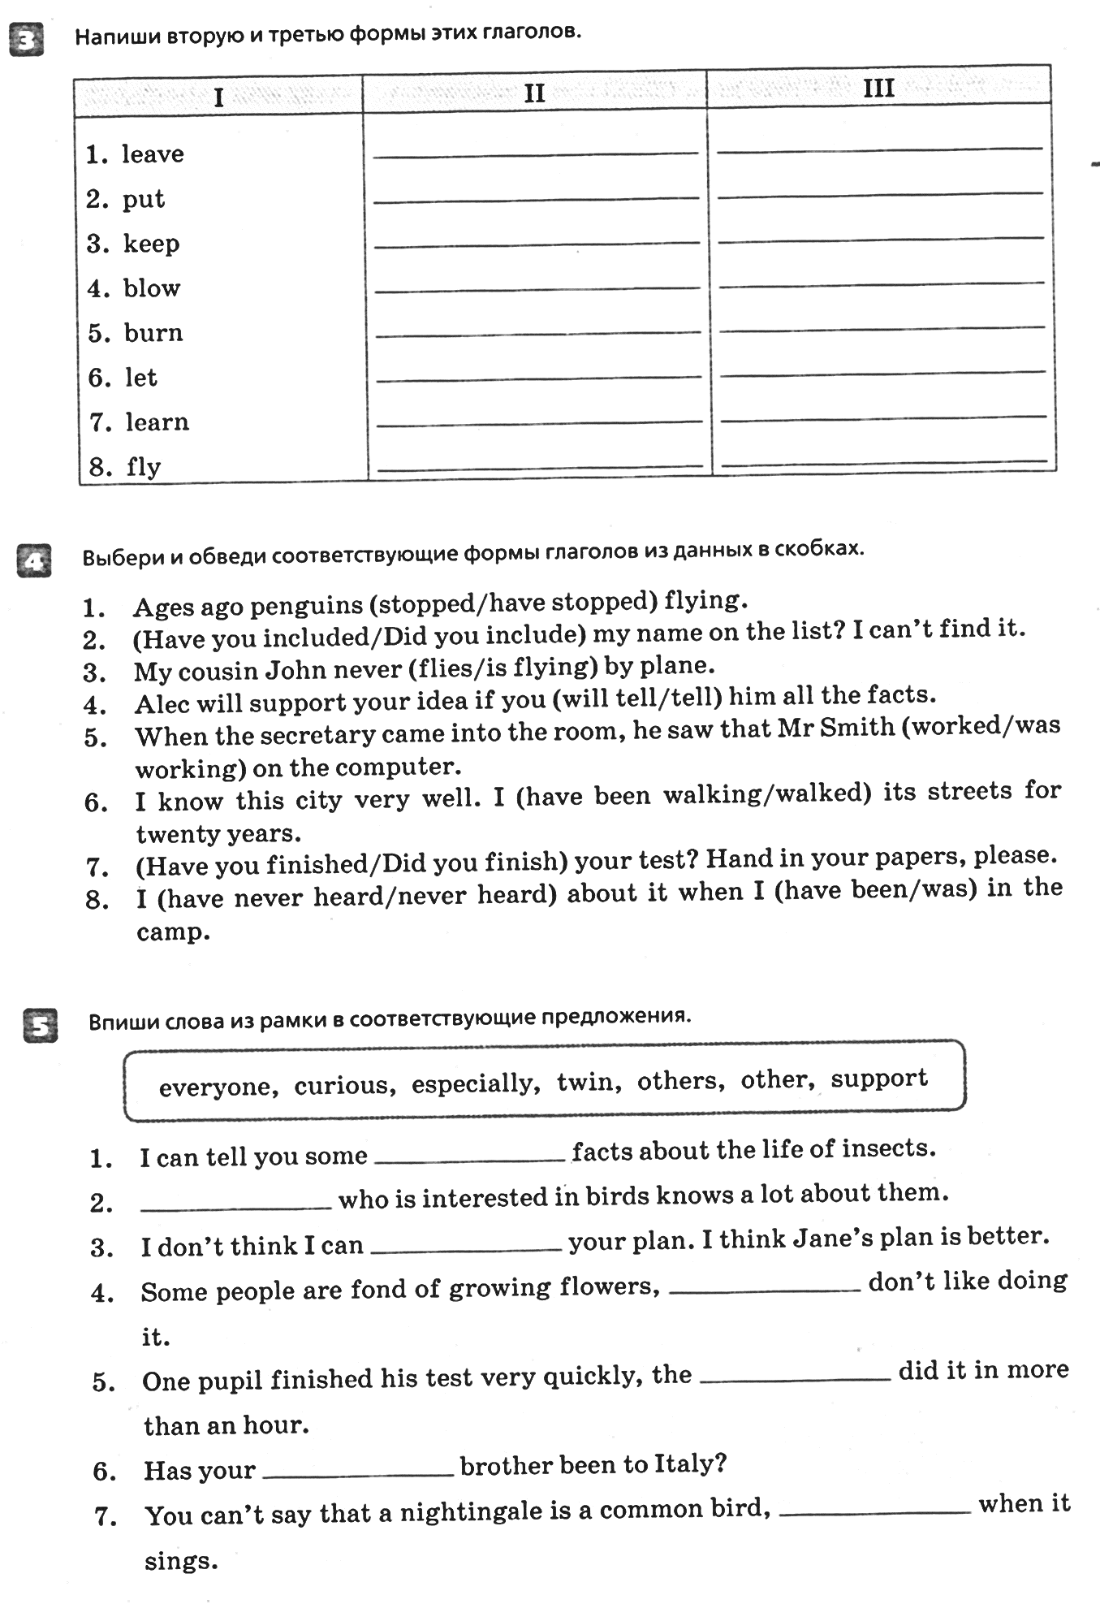

Вариант 2
1. Переведи на английский язык
1) божья коровка, 2) дятел, 3) сова, 4) пингвин, 5) сорока, 6) гусеница, 7) паук, 8) соловей
2. Напиши пожелания и поздравления по-английски
1) Поздравь своего учителя:
с днем Учителя, с Новым годом, с Пасхой
2) Пожелай хорошего дня
3. Напиши вторую и третью формы этих глаголов
draw forget hear know
grow burn dream prefer
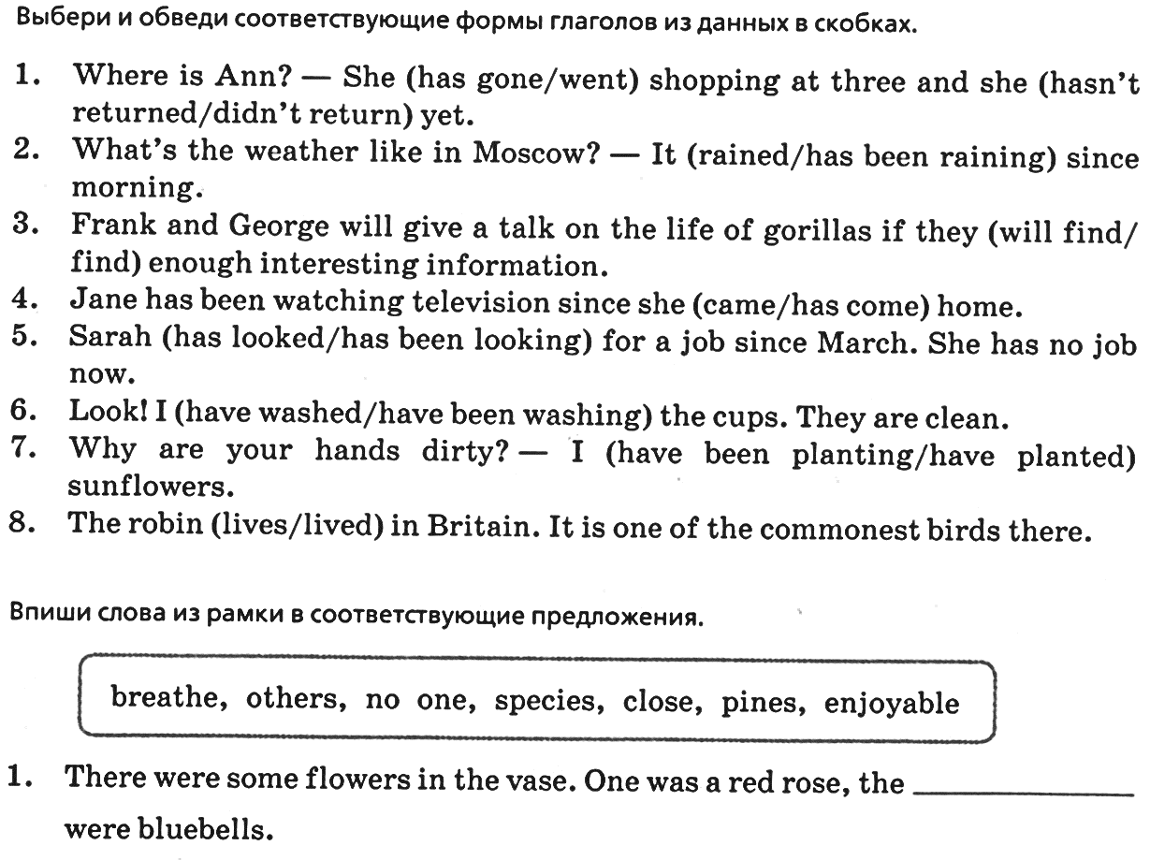
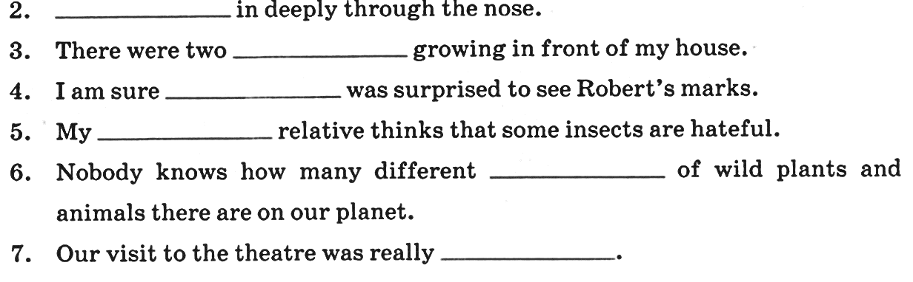

Контрольная работа 7 класс. 4 четверть
1. Complete the sentences. Use reflexive pronouns where necessary.
- My twelve-year-old daughter made this cake _______________.
- Dan always shaves _____________ in the morning.
- Nobody helps him. He did everything _______________.
- They never buy bread in the shop. They make it ______________.
- Did you enjoy _______________ at the concert?
2. Use Present Perfect or Present Perfect Progressive of the verbs to complete the sentences.
- I (have been doing/have done) the flat since 2 o’clock.
- This factory (has polluted/has been polluting) the air for 12 years.
- John (has owned/has been owning) this house for 15 years.
- He (has worked/has been working) as a driver since 1996.
- I (have met/have been meeting) Mr Black only once, I don’t know what kind of person he is.
3. Choose the right words to complete the sentences. Use few/a few; little/a little.
- Can you wait for (a few/few) minutes, please?
- Everybody needs (a little/little) comfort.
- There are (few/a few) parks in the city, that’s why I think it so polluted.
- I have (a few/few) apples, so I can make a pie.
- Is there any bread in basket? Can I have a sandwich? – Yes, there is (little/a little).
4. Use the appropriate verbs from the box to complete the sentences.
make, stay, give, hand, talk, take
- _________________your coat off and go to the dining room.
- Are you going to _____________ up all night? It’s time to go to bed.
- Polly, can you ____________ out your tests to the pupils, please?
- The plane is due to ___________off in several minutes.
- The girls started to ___________ up the party.

